NumericTypes Test

|  |  |  |  |  |
| --- | --- | --- | --- | --- |
| First score | Second score | Average | Temperature in Fahrenheit | Temperature in Celsius |
| 100 | 50 | 75 | 55 | 12.777779 |
| 88 | 66 | 77 | 32 | 0 |
| 54 | 99 | 76 | 112 | 44.444444 |

SphereVolume Test

|  |  |  |
| --- | --- | --- |
| Diameter | Volume (hand calculated) | Volume (resulting output) |
| 2 | 4.19 | 4.1887902047863905 |
| 25.4 | 8580.25 | 8580.24664605096 |
| -5 | -65.45 | -65.44984694978736 |

CMD Prompt Screenshot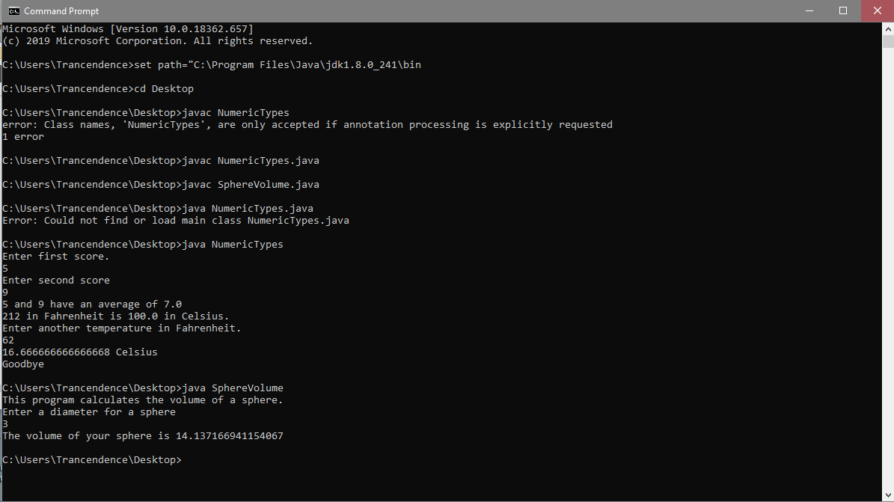

SphereVolume Screenshot

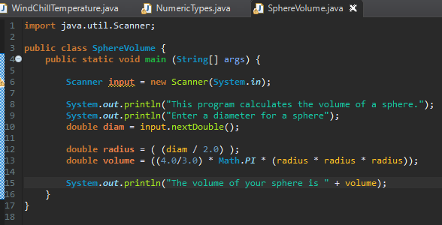

NumericTypes Screenshot

